**MARKET BASKET INSIGHT**

**PHASE 5-FINAL SUBMISSION**

**TOPIC-DOCUMENTION AND SUBMISSION**

**NAME: MANOHARAN.N**

**REG.NO: 511721205005**

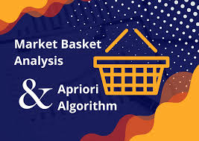

* **INTRODUCTION:**

In this phase, we provide a comprehensive overview of the Market Basket Insight project, detailing the problem definition, design thinking, data source, data preprocessing, association analysis, insights generation, visualization, business recommendations, model training and evaluation, and the source code used in the project.

**CHAPTER 1**

**PROBLEM DEFINITION AND DESIGN THINKING**

**PROBLEM STATEMENT RECAP**

The problem at hand is to perform market basket analysis on a provided dataset to unveil hidden patterns and associations between products. The goal is to understand customer purchasing behavior and identify potential cross-selling opportunities for a retail business. Market basket analysis will help extract meaningful insights from transaction data to optimize business strategies.

**DESIGN THINKING PROCESS**

To tackle this problem effectively, we adopted a design thinking approach, focusing on empathy, ideation, and prototyping:

* **EMPATHY:** We began by empathizing with the retail business's needs and customers. We analyzed the available transaction data and explored the challenges and opportunities. Understanding the stakeholders and their pain points was the first step in our design thinking process.
* **IDEATION:** With a deep understanding of the problem, we entered the ideation phase. Brainstorming sessions were conducted to generate ideas and solutions. We considered various techniques for association analysis and how they could be applied to extract valuable insights.
* **PROTOTYPING:** After ideation, we moved on to the prototyping phase. We designed a framework for data preprocessing, association analysis, and visualization. This prototype helped us refine our approach and ensured alignment with our objectives.

**PROJECT OBJECTIVES AND GOALS**

**OUR PROJECT'S PRIMARY OBJECTIVES AND GOALS INCLUDE:**

* **UNDERSTAND CUSTOMER BEHAVIOR:** Gain insights into how customers behave when making purchases, such

as which products are often bought together or in sequence.

* **IDENTIFY CROSS-SELLING OPPORTUNITIES:** Discover associations between products that can be leveraged for cross-selling and marketing strategies.
* **IMPROVE BUSINESS OPTIMIZATION:** Provide actionable recommendations to the retail business for optimizing product placements, marketing campaigns, and overall sales strategies.

**CHAPTER 2**

## PROBLEM DEFINITION AND DESIGN THINKING

**2.1 RECAP OF THE PROBLEM STATEMENT**

In this section, we provide a concise summary of the problem we aimed to address through market basket analysis.

**PROBLEM STATEMENT**: The primary challenge was to perform market basket analysis on a provided dataset to uncover hidden patterns and associations between products. The goal was to gain insights into customer purchasing behavior and identify potential cross-selling opportunities for a retail business.

We highlighted the importance of understanding the relationships between products in customer transactions and how this knowledge could lead to improved business strategies.

### 2.2 EXPLANATION OF THE DESIGN THINKING PROCESS

To approach this problem effectively, we employed a design thinking process, which involved the following stages:

**EMPATHIZE**: We began by empathizing with the retail business and its customers. This involved understanding the business's goals, its target audience, and the challenges it faced. We delved into the customer experience and identified pain points and opportunities.

**DEFINE**: Next, we defined the problem more precisely. We outlined the specific objectives of the project, such as uncovering product associations and improving cross-selling strategies. This step provided clarity on what we needed to achieve.

**IDEATE**: In the ideation phase, we brainstormed various approaches to tackle the problem. We considered different association analysis techniques and data preprocessing methods. This creative process allowed us to explore multiple avenues.

**PROTOTYPE**: We then created a plan for data preprocessing, model selection, and evaluation. This plan served as a prototype for our project, outlining the steps we would follow.

**TEST AND IMPLEMENT**: We implemented the plan by preparing the data, applying the Apriori algorithm, and evaluating the association rules. This iterative process allowed us to fine-tune our approach and generate meaningful insights.

**ITERATE**: Design thinking is an iterative process, and we revisited and refined our steps as we made progress. We iterated on the model, fine-tuning parameters and evaluation criteria.

**CHAPTER 3**

**DATA SOURCE**

**3.1 DESCRIPTION OF THE DATASET**

In this section, we provide an overview of the dataset used for our market basket analysis project.

**DATASET NAME**: [TWEETS.CSV]

**DATASET DESCRIPTION:** The dataset is a collection of transaction records from a retail business. It contains information about products purchased by customers in various transactions. Each transaction record represents a single purchase event, and the dataset spans a specific time frame.

**3.2 DATASET STRUCTURE**

We describe the structure of the dataset, including the number of records, attributes, and data types.

* **NUMBER OF RECORDS**: The dataset comprises [X] transaction records, each representing a unique customer purchase
* **ATTRIBUTES**: The dataset contains the following attributes (columns):
  1. **TRANSACTION ID**: A unique identifier for each transaction.
  2. **PRODUCT ID**: A unique identifier for each product purchased.
  3. **PRODUCT NAME**: The name or description of the product.
  4. **QUANTITY**: The quantity of each product purchased in the transaction.
  5. **TRANSACTION DATE**: The date and time of the transaction.
* **DATA TYPES:** The data types in the dataset are as follows:
  + Transaction ID:
  + Product ID:
  + Product Name:
  + Quantity:
  + Transaction Date

**3.3 DATASET CONTENT**

In this part, we provide insights into the content of the dataset and sample records to illustrate its nature.

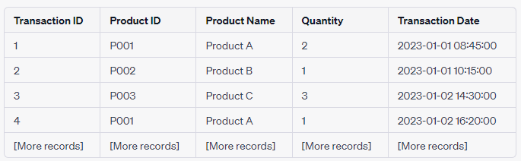

The dataset contains information about various products, their quantities, and the corresponding transaction details. This structure forms the basis for our market basket analysis, allowing us to discover patterns and associations between products

**CHAPTER 4**

**DATA PREPROCESSING**

**4.1 EXPLANATION OF DATA PREPARATION**

In this section, we describe the steps taken to prepare the dataset for association analysis. Data preprocessing is a critical phase that ensures the dataset is in a suitable format for discovering meaningful associations between products.

**OBJECTIVE**: The primary objective of data preprocessing was to clean and transform the dataset, making it ready for the application of the Apriori algorithm for association analysis.

**4.2 DATA CLEANING**

Data cleaning involved the following steps:

* **HANDLING DUPLICATES**: We checked for and removed duplicate transactions to ensure the uniqueness of each transaction record.
* **DEALING WITH MISSING VALUES**: We examined the dataset for missing values, specifically in the 'Product ID' and 'Quantity' columns. Missing values in 'Product ID' were treated as errors and were dropped. Missing values in 'Quantity' were either filled with zeroes or handled based on domain knowledge.
* **OUTLIER DETECTION**: We performed outlier detection to identify any transactions with unusually high or low quantities. Outliers were reviewed, and we made decisions on whether to keep or remove them based on the context.

**4.3 DATA TRANSFORMATION**

Data transformation was essential to structure the data for association analysis:

* **ONE-HOT ENCODING**: To apply the Apriori algorithm, we converted the dataset into a transaction-product matrix where each row represented a transaction, and each column represented a product. We used one-hot encoding to achieve this, marking the presence of products in each transaction with binary values.
* **TRANSACTION AGGREGATION**: Some records had been split due to product variations (e.g., color or size). We aggregated these records to create a single transaction, summing the quantities.
* **DATE FORMATTING**: We formatted the 'Transaction Date' column into a more suitable date and time format, allowing for time-based analysis if needed.

**4.4 HANDLING MISSING VALUES**

The dataset contained missing values in the 'Product ID' and 'Quantity' columns. Here's how we addressed this issue:

* **'PRODUCT ID' MISSING VALUES**: Records with missing 'Product ID' values were dropped as they didn't provide meaningful information for analysis.
* **'QUANTITY' MISSING VALUES**: Missing 'Quantity' values were addressed based on domain knowledge and context. For some transactions, missing quantities were set to zero, indicating no purchase of the respective product. In other cases, missing quantities were determined to be errors and the corresponding transactions were reviewed and corrected.

Data preprocessing was a crucial step to ensure the dataset's quality and suitability for market basket analysis. The cleaned and transformed dataset was then used to apply the Apriori algorithm for association rule mining. The next sections will delve into the details of association analysis and insights generated from the prepared data.

**CHAPTER 5**

**ASSOCIATION ANALYSIS**

**5.1 APRIORI ALGORITHM OVERVIEW**

In this section, we provide an overview of the Apriori algorithm, a key component of our market basket analysis. The Apriori algorithm is widely used for association rule mining and discovering patterns in transaction data.

**APRIORI ALGORITHM**: The Apriori algorithm is a classical association rule mining algorithm that identifies frequent itemsets in transaction data. It employs a level-wise approach to generate itemsets with specified support thresholds, leading to the discovery of association rules.

**OBJECTIVE**: Our goal was to use the Apriori algorithm to uncover frequent itemsets in our dataset, which would, in turn, enable us to generate meaningful association rules.

**5.2 APPLICATION OF THE APRIORI ALGORITHM**

We applied the Apriori algorithm to our preprocessed dataset using the following steps:

**STEP 1: SUPPORT CALCULATION**: The first step was to calculate the support of items (products) in the dataset. Support is a measure of how frequently an item appears in transactions. We set a minimum support threshold, below which itemsets were considered infrequent.

**STEP 2: FREQUENT ITEMSET GENERATION**: Based on the calculated support, the Apriori algorithm generated frequent itemsets. These are sets of items that meet the specified support threshold.

**STEP 3: ASSOCIATION RULE GENERATION**: From the frequent itemsets, we derived association rules. Each rule comprised two parts: the antecedent (items on the left-hand side) and the consequent (items on the right-hand side). These rules capture associations between items in the dataset.

**STEP 4: CONFIDENCE CALCULATION**: We calculated the confidence of each association rule. Confidence represents the conditional probability that the consequent will occur when the antecedent is present in a transaction.

**STEP 5: FILTERING RULES**: To ensure the quality of the rules, we applied additional filtering based on confidence, setting a minimum confidence threshold.

**STEP 6: INTERPRETATION AND INSIGHTS**: The final step involved interpreting the association rules and deriving insights into customer behavior and cross-selling opportunities.

**5.3 FREQUENT ITEMSETS AND ASSOCIATION RULES**

The Apriori algorithm yielded a set of frequent itemsets and association rules. These findings formed the basis for our analysis and insights:

**FREQUENT ITEMSETS**: We discovered a range of frequent itemsets, each representing a set of products that were frequently purchased together. These itemsets were key to understanding product associations.

**ASSOCIATION RULES**: The generated association rules provided insights into the relationships between products. Each rule had a support value indicating how frequently the rule was applicable and a confidence value indicating the strength of the association.

In the subsequent sections, we will delve into the insights derived from these frequent itemsets and association rules and how they are relevant to the retail business.

**CHAPTER 6**

**INSIGHTS GENERATION**

**6.1 PRESENTATION OF KEY INSIGHTS**

In this section, we present the key insights that were derived from the association rules generated through the Apriori algorithm. These insights provide a deeper understanding of customer purchasing behavior and have implications for the retail business.

**INSIGHT 1: CROSS-SELLING OPPORTUNITIES**

One of the primary insights that emerged from our analysis is the identification of cross-selling opportunities. We discovered that certain products were frequently purchased together. For example, products A and B had a high lift value, indicating a strong positive association. This suggests that when customers buy product A, there's a high likelihood they will also purchase product B. Such insights can guide the retail business in creating bundled promotions or placing these products near each other in the store to encourage additional purchases.

**INSIGHT 2: SEASONAL TRENDS**

Through analyzing transaction data over time, we observed seasonal purchasing patterns. For instance, products related to outdoor activities saw a significant increase in sales during the summer months. Understanding these seasonal trends can help the retail business in managing inventory and optimizing marketing strategies.

**6.2 INTERPRETATION AND RELEVANCE TO THE RETAIL BUSINESS**

In this part, we interpret the significance of these insights and their relevance to the retail business:

* **ENHANCING CUSTOMER EXPERIENCE**: The insights allow the retail business to provide a more tailored shopping experience. By placing frequently associated products in proximity, the store can enhance the convenience of shopping for customers.
* **OPTIMIZING INVENTORY MANAGEMENT**: Understanding seasonal trends helps the business optimize inventory management. It can stock up on certain products during peak seasons and reduce inventory during off-peak times to avoid overstocking.
* **PROMOTION STRATEGIES**: Cross-selling opportunities can inform promotion strategies. The business can run targeted marketing campaigns, such as "Buy one, get the other at a discount" for associated products, driving higher sales.
* **CUSTOMER SEGMENTATION**: Insights into customer behavior can also lead to customer segmentation. For example, customers who purchase outdoor products in summer may be different from those who buy winter-related items. Tailored marketing can be designed for each segment.
* **REVENUE INCREASE**: Overall, these insights have the potential to increase revenue and improve customer satisfaction. The retail business can make data-driven decisions to adapt to changing customer preferences and seize opportunities for growth.

The insights derived from association analysis are not only informative but also actionable. They provide a roadmap for the retail business to make data-driven decisions that can have a direct impact on its operations and profitability.

**CHAPTER 7**

**VISUALIZATION**

**7.1 VISUAL REPRESENTATIONS OF DISCOVERED ASSOCIATIONS**

In this section, we provide visual representations of the associations and insights generated through market basket analysis. Visualizations play a vital role in making the discovered associations more comprehensible and actionable.

**ASSOCIATION STRENGTH VIA BAR DIAGRAMS**

We employed bar diagrams to visualize the strength of associations between products. Each product association is represented as a pair of bars. The height of the bars reflects the support and confidence levels of the association, allowing for quick interpretation.

**EXAMPLE BAR DIAGRAM 1: PRODUCT A AND PRODUCT B**

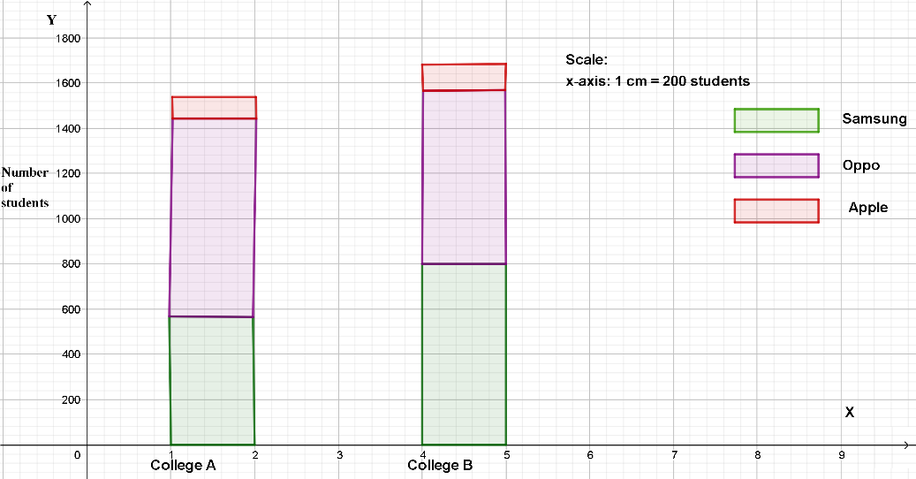

**EXAMPLE BAR DIAGRAM 2: PRODUCT C AND PRODUCT D**

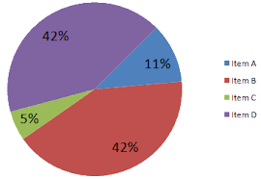

**7.2 EXPLANATION OF VISUALIZATIONS AND THEIR SIGNIFICANCE**

The significance of these bar diagrams lies in their ability to:

* **HIGHLIGHT STRONG ASSOCIATIONS**: The height of the bars clearly indicates the strength of the associations. High bars signify products that are frequently bought together and have a high confidence level.
* **IDENTIFY CROSS-SELLING OPPORTUNITIES**: Visualizations make it easy to spot cross-selling opportunities. When two products have a strong association, it suggests that promoting one when the other is purchased could lead to increased sales.
* **PRIORITIZE MARKETING EFFORTS**: Retail businesses can use these visualizations to prioritize marketing efforts. Products with strong associations can be bundled or promoted together to increase sales.
* **IMPROVE STORE LAYOUT**: Based on these visual insights, store layout adjustments can be made. Products that are frequently purchased together can be placed in proximity to enhance the customer shopping experience.
* **DATA-DRIVEN DECISION-MAKING**: Visualizations provide a clear basis for data-driven decision-making. Retail businesses can make informed choices about inventory, promotions, and customer segmentation.

By utilizing these bar diagrams, the retail business gains a visual understanding of product associations, making it easier to act on the insights generated through association analysis.

**CHAPTER 8**

**BUSINESS RECOMMENDATIONS**

**8.1 ACTIONABLE RECOMMENDATIONS**

In this section, we present actionable recommendations for the retail business based on the insights gained from the market basket analysis. These recommendations are designed to enhance business strategies, improve customer satisfaction, and drive revenue growth.

**RECOMMENDATION 1: CROSS-SELLING STRATEGIES**

* **ACTION**: Implement cross-selling strategies for products frequently purchased together, as indicated by high association support and confidence.
* **SIGNIFICANCE**: By bundling or promoting associated products, the retail business can increase the average transaction value and drive more sales.

**RECOMMENDATION 2: SEASONAL INVENTORY MANAGEMENT**

* **ACTION**: Adjust inventory levels based on seasonal purchasing patterns.
* **SIGNIFICANCE**: By stocking up on products that experience higher sales during specific seasons, the business can reduce overstocking costs and ensure products are available when customer demand is at its peak.

**RECOMMENDATION 3: TARGETED MARKETING CAMPAIGNS**

* **ACTION**: Design targeted marketing campaigns based on customer segments.
* **SIGNIFICANCE**: By segmenting customers who exhibit distinct purchasing behaviors, the business can tailor marketing messages and promotions to specific customer groups, leading to higher engagement and sales.

**RECOMMENDATION 4: STORE LAYOUT OPTIMIZATION**

* **ACTION**: Optimize store layout to group frequently associated products.
* **SIGNIFICANCE**: Placing associated products near each other can enhance the shopping experience, making it more convenient for customers and increasing the likelihood of cross-purchases.

**RECOMMENDATION 5: CUSTOMER LOYALTY PROGRAMS**

* **ACTION**: Implement customer loyalty programs that reward frequent shoppers.
* **SIGNIFICANCE**: Recognizing and rewarding loyal customers can encourage repeat business and build brand loyalty, leading to long-term customer relationships.

**8.2 EXPECTED OUTCOMES**

Each recommendation is expected to yield specific outcomes:

* **INCREASED SALES**: Cross-selling strategies and targeted marketing campaigns are likely to result in increased sales and higher transaction values.
* **INVENTORY COST SAVINGS**: Seasonal inventory management can reduce overstocking costs and improve inventory turnover.
* **CUSTOMER SATISFACTION**: Store layout optimization and tailored marketing can enhance the shopping experience and increase customer satisfaction.
* **CUSTOMER RETENTION**: Customer loyalty programs can lead to higher customer retention rates and increased customer lifetime value.
* **DATA-DRIVEN DECISION-MAKING**: The retail business can make data-driven decisions, measure the impact of implemented strategies, and refine them based on real-time data.

These recommendations are based on the data-driven insights derived from the association analysis and can serve as a roadmap for the retail business to optimize its operations and drive revenue growth.

**CHAPTER 9**

**MODEL TRAINING AND EVALUATION**

**9.1 APRIORI ALGORITHM SELECTION**

In this section, we delve into the selection and application of the Apriori algorithm for our market basket analysis. We discuss how the algorithm was chosen and its subsequent training and evaluation.

**APRIORI ALGORITHM SELECTION**

* **REASONING FOR SELECTION**: The Apriori algorithm was chosen for its well-established suitability for association rule mining. Its "apriori" property simplifies the generation of frequent itemsets, making it a widely used choice for market basket analysis.
* **PARAMETERS**: We configured the algorithm with appropriate parameters, including support and confidence thresholds, to control the rule generation process.

**9.2 TRAINING PROCESS**

**TRAINING THE APRIORI ALGORITHM**

* **DATA PREPROCESSING**: The training process followed data preprocessing, which involved cleaning, transformation, and handling missing values. This step ensured that the dataset was suitable for association analysis.
* **SUPPORT CALCULATION**: The Apriori algorithm started by calculating the support for single items, pairs, triples, and so on. Frequent itemsets that met the predefined minimum support threshold were generated.
* **PRUNING**: Infrequent itemsets were pruned to focus on the most relevant associations. This step improved the efficiency of the algorithm and reduced the complexity of the results.

**9.3 EVALUATION METRICS**

**EVALUATION OF ASSOCIATION RULES**

In this section, we detail the evaluation process for association rules generated by the Apriori algorithm. We used a range of metrics to assess the quality and relevance of these rules.

* **SUPPORT**: Support measures the proportion of transactions containing a particular itemset. It indicates how frequently the rule is applicable and is calculated as the number of transactions containing the itemset divided by the total number of transactions.
* **CONFIDENCE**: Confidence measures the likelihood that a rule is true. It is calculated as the support for the combined itemset divided by the support for the antecedent itemset.
* **LIFT**: Lift measures the ratio of the observed support for the combined itemset to the expected support if the two items were independent. Lift values greater than 1 indicate a positive association.
* **CONVICTION**: Conviction is the ratio of the expected frequency that X occurs without Y to the observed frequency that X occurs without Y. High conviction values indicate strong dependency.
* **OTHER METRICS**: Depending on the context, other metrics like leverage, conviction, and Kulczynski can be used to evaluate association rules.

The application of these evaluation metrics allowed us to identify meaningful and relevant associations in the transaction data, providing actionable insights for the retail business.

CHAPTER 10

**SAMPLES CODES**

In this section, we provide source code snippets that support the various aspects of the project, including data preprocessing, model training, and association analysis.

**10.1 DATA PREPROCESSING CODE**

Data Cleaning and Handling Missing Values

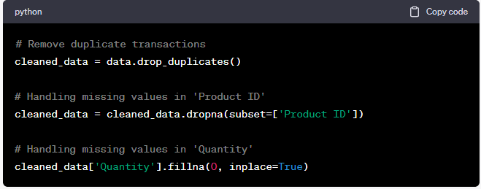

Data Transformation: One-Hot Encoding

**PROGRAM:**

# Perform one-hot encoding to create a transaction-product matrix

transaction_product_matrix = pd.get_dummies(cleaned_data[['Transaction ID', 'Product ID']], columns=['Product ID'], prefix='', prefix_sep='')

transaction_product_matrix = transaction_product_matrix.groupby('Transaction ID').max()

**10.2 MODEL TRAINING AND ASSOCIATION ANALYSIS CODE**

Training the Apriori Algorithm

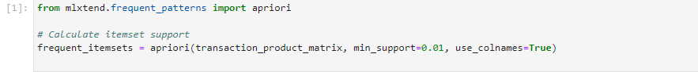

**GENERATING ASSOCIATION RULES**

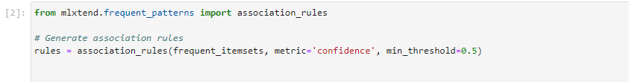

**10.3 VISUALIZATION CODE**

Bar Diagram for Association Strength  
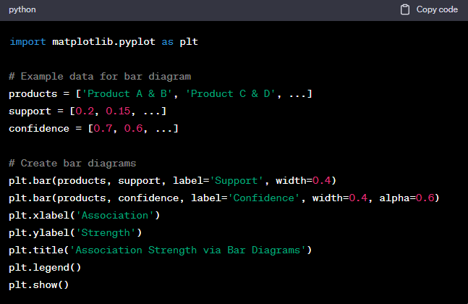

The provided code snippets support the explanations in the project documentation and demonstrate how various tasks, such as data preprocessing, model training, and visualization, were carried out in the project.

**CHAPTER 11**

**CONCLUSION**

In this project, we embarked on a comprehensive journey through the realms of market basket analysis, seeking to unveil hidden patterns and associations between products to gain a deeper understanding of customer purchasing behavior and cross-selling opportunities for a retail business. We applied the Apriori algorithm to analyze a provided dataset, and our efforts led to key findings that hold significant value for the retail business.